Client & Server System

Instructor: Dr. Richard Lomotey

Team members:

Jingyuan Wei(jiw149)

Ruochi Zhang(ruz41)

Final Project Report

Wechat Robot

1.Thorough description of the project

We designed a automatic reply system for a very popular chatting app among Asian people which called “wechat”. Users can use this client server system to log in their own account and perform many functions.

Here are the functions and open source corpus that we use:

(1)A Chinese language processor introduced from “Tuling” database.

(2)A automatic translator based on google translate.

(3)A automatic make-up function for portrait photograph based on facial recognition and image processing method.

(4)A PDF ORC function to transform literature content in PDF file to txt form.

2.Main open source parallel corpus (OPUS) and database we use.

(1)Baidu translation api from Baidu platform (Function : Translate English to Chinese)





(2) “TULING” Chinese language corpus.

(Function : Auto reply in Chinese)



<http://www.tuling123.com/v1/kb/select> (api interface)

3.Project instruction

1. Downlaod wechat app in Apple Store or Andrid Store
2. Run in commandline: python3 wechat_robot.py
3. Scan the QR code

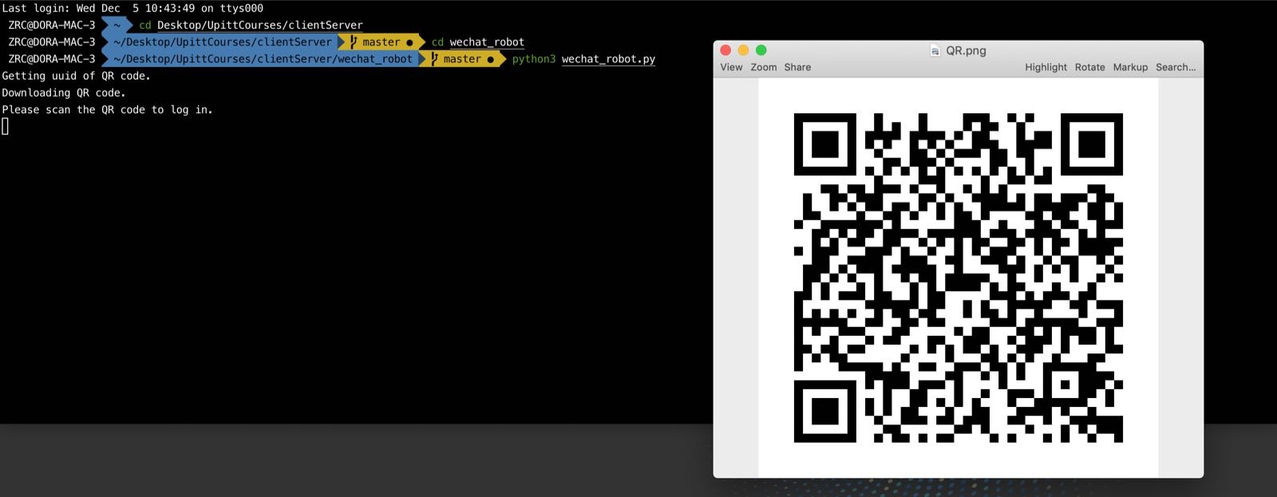

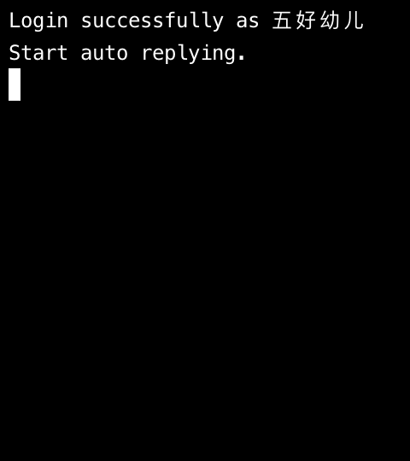

4.Function description and Demo

Function Demo-Part I:

Auto Reply

We used Baidu translate api to frist translate English message into Chinese, and then use Tuling Chinese corpus to generate an auto reply and translate it back to English and send.

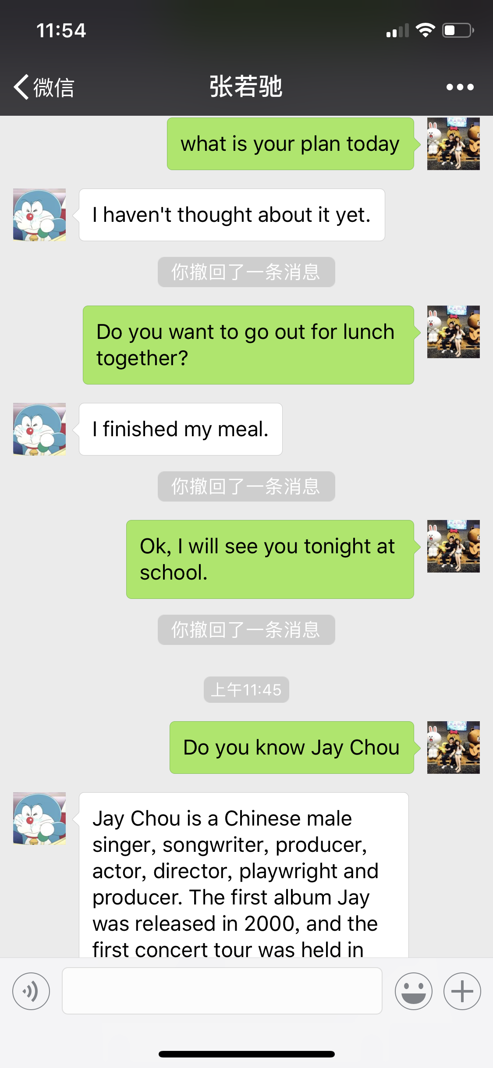

Function Demo-Part II:

Auto make-up

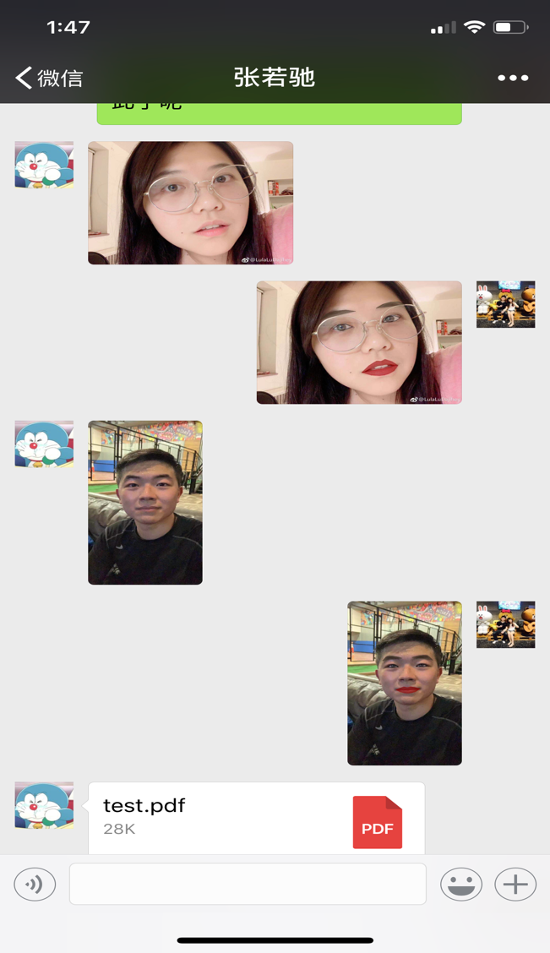Before



After



Here we use our facial recognition methods to detect certain parts in human face(such as eyes, eyebrows and lips) and then do the image processing to add make-ups(lipsticks and eye lines). Finally we get the output picture with make-ups on.

Function Demo Part III:

PDF transform using PDF OCR technique

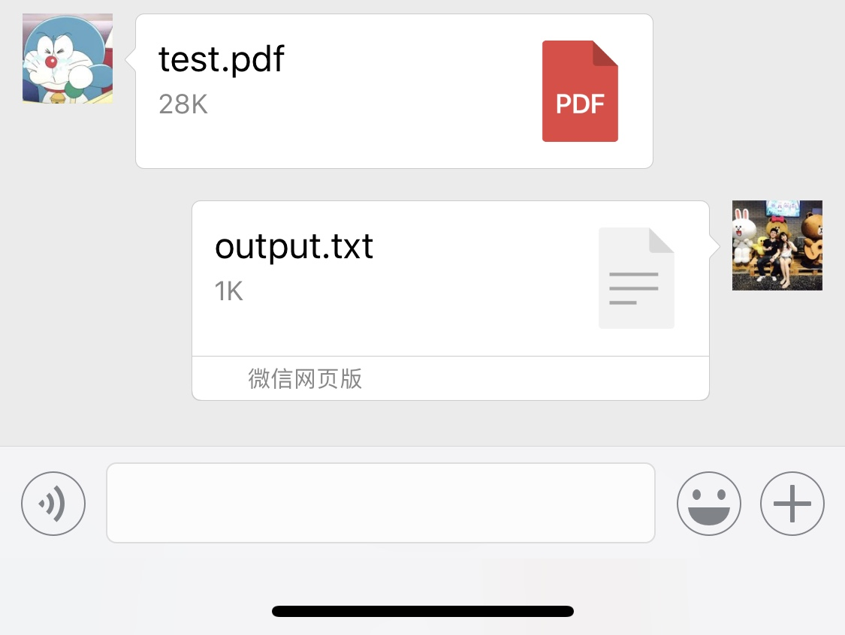

 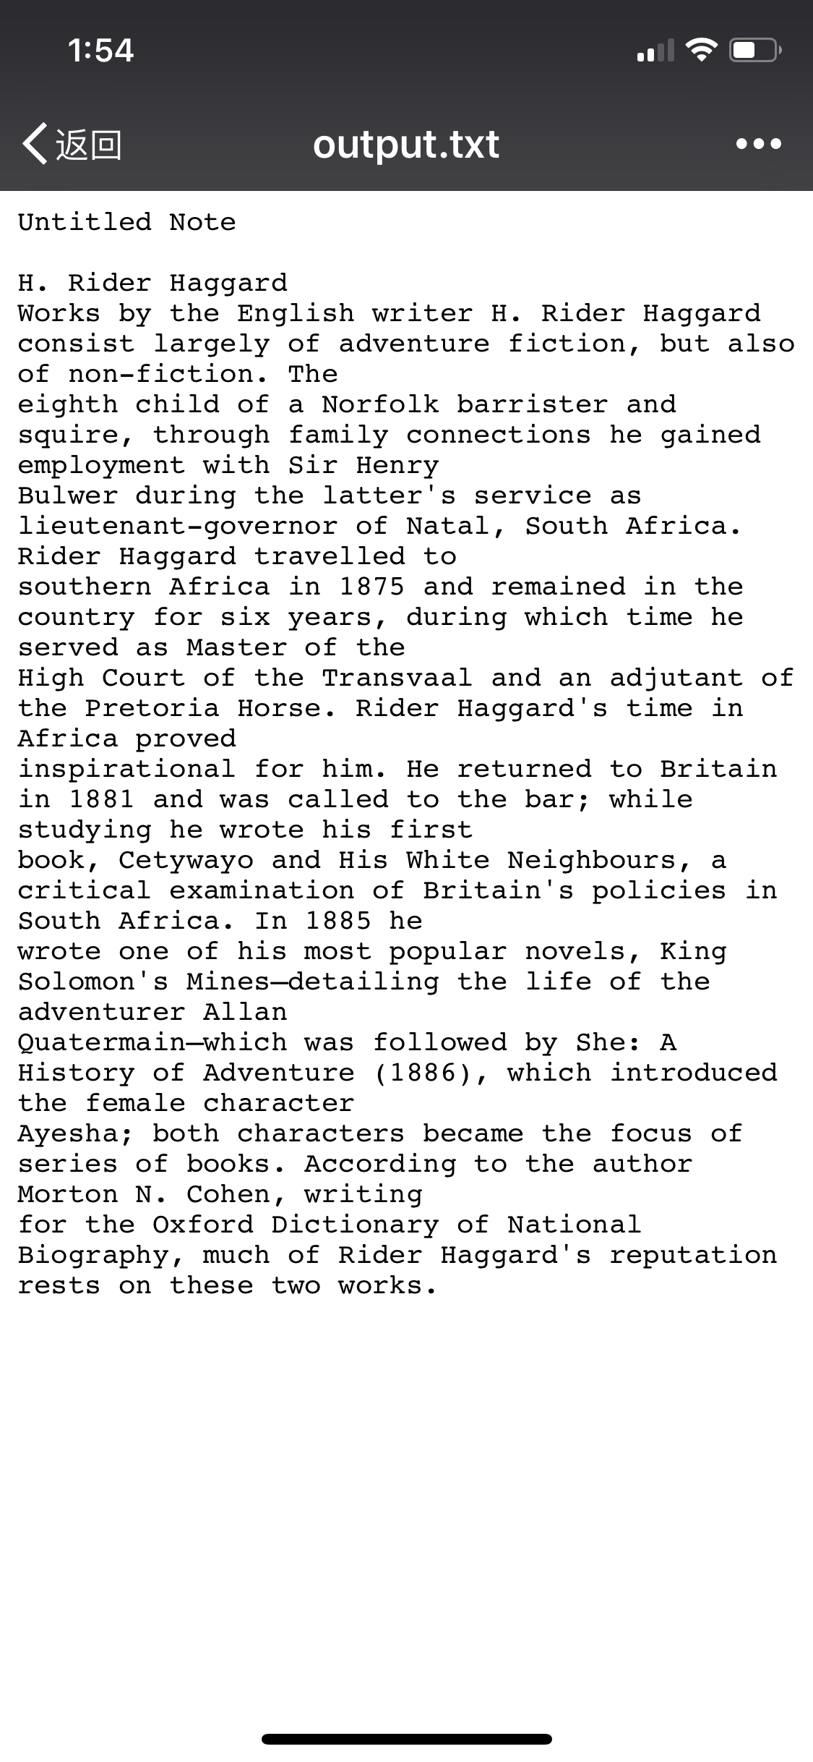

5.Wrap up.

We have learned so much from the Client-Server System course this semester, and we applied those knowledge to design our own system successfully. Hope this chatting robot can be helpful for those people who use wechat.